How do you roll back the transaction in Apache Kafka?
Kafka doesn’t have traditional rollback.
- Producer: Use transactions → abortTransaction() discards messages
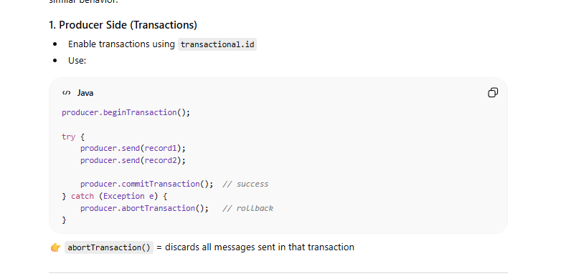
- Consumer: Don’t auto commit offset → messages are reprocessed
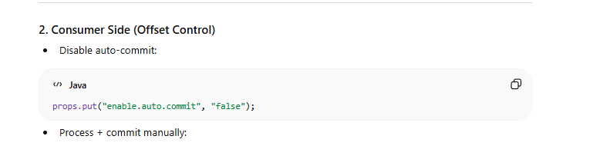
What is auto commit in kafka ?
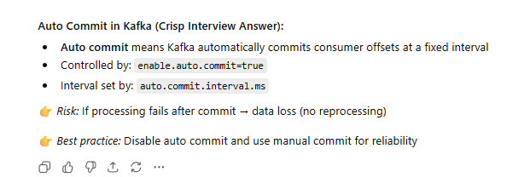
How does the kafka process message restoration if communication breakdown?
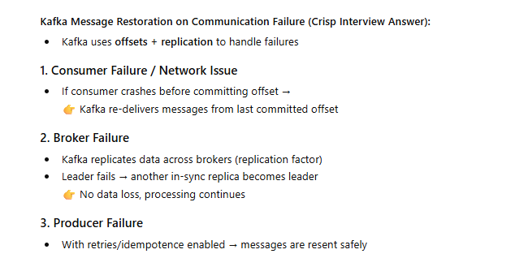
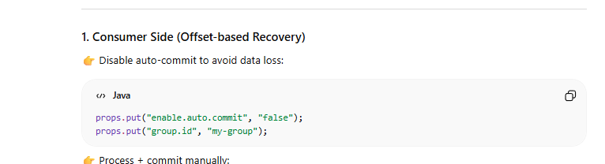
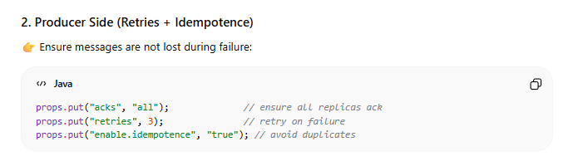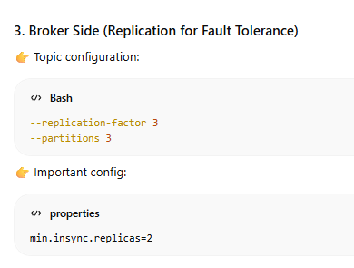
How does kafka ensure fault tolerant?
Kafka Fault Tolerance (Crisp Interview Answer):
- Replication: Data is replicated across multiple brokers (replication factor)
- Leader–Follower Model: Each partition has a leader + replicas
- Failover: If leader fails → an in-sync replica (ISR) becomes new leader
- Acknowledgment (acks=all): Ensures data is written to all replicas
- Offset Management: Consumers can re-read messages if failure occurs
what is isr in-sync repilca and how it is different from replication factor? 👉 Replication factor defines total replicas, ISR defines only the healthy synced replicas used for failover
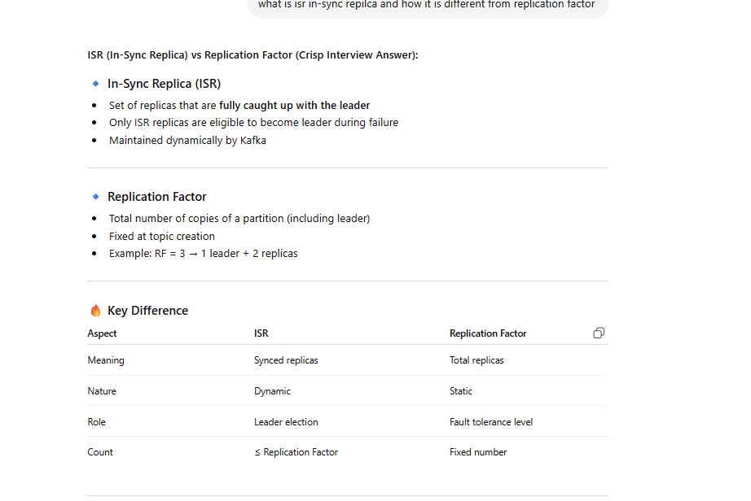
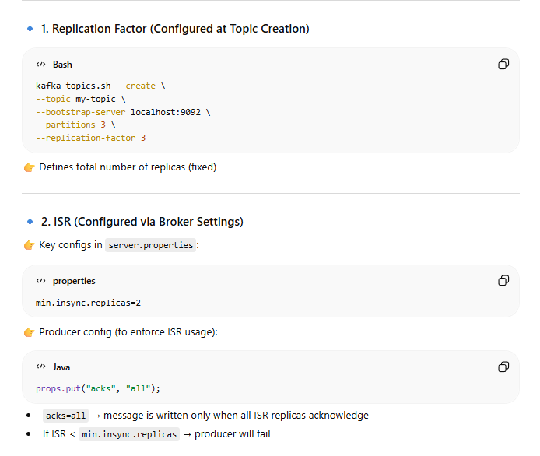
What is leader election ?
Leader election is the process of selecting a new partition leader from ISR when the current leader fails to ensure high availability
What is group id in consumers what features it provide?
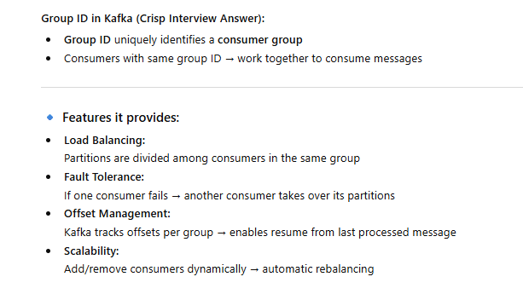
what is zookeeper in kafka?
ZooKeeper is used for cluster coordination and metadata management in Kafka
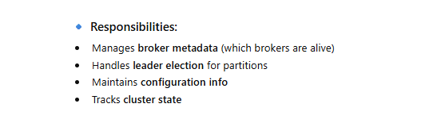
What is the difference between a Kafka consumer and consumer group?
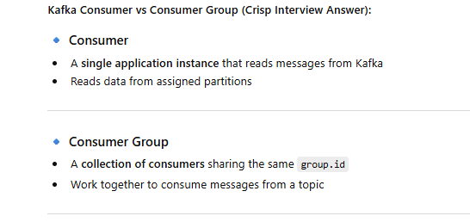
What is the purpose of the offset in Kafka?
Offset is used to track and control message consumption, enabling resume and reprocessing
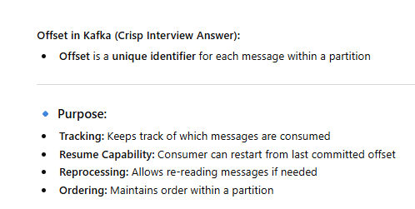
what is partioning key ?
👉 Partitioning key decides message distribution and ensures ordering within a partition
